


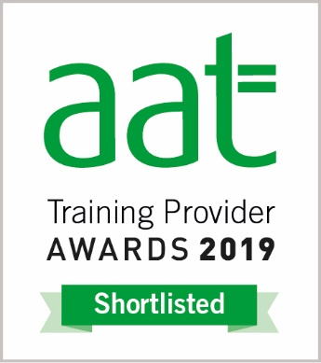

EXAM APPLICATION FORM - AAT
PERSONAL DETAILS
First name: | Surname:
Telephone No.:
E-Mail address

Date of Birth | Your AAT Registration No:
PLEASE STATE WHERE YOU FIRST HEARD ABOUT OUR CENTRE

PLEASE FILL IN THE DATE AND TIME BESIDE EACH EXAM YOU WISH TO SIT BELOW
AQ 2022 EXAMS
AAT LEVEL 1 | AAT LEVEL 2 | AAT LEVEL 3 | AAT LEVEL 4
ABK – Award in Bookkeeping | TBK: Introduction to Bookkeeping | BUAW: Business Awareness | AMAC: Applied Management Accounting
 | POBC: Principles of Bookkeeping Control | FAPS: Financial Accounting: Preparing Financial Statements | DAIF: Drafting and Interpreting Financial Statements
 | PCTN: Principles of Costing | MATS: Management Accounting Techniques | INAC: Internal Accounting Systems and Control
 | BENV: The Business Environment (Synoptic) | TPFB: Tax Process for Business | BNTA: Business Tax
 | EPA In-Tray | EPA - Synoptic | PNTA: Personal Tax
 |  |  | CRDM: Credit & Debt Management
 |  |  | CAFM: Cash & Financial Management
 |  |  | AUDT Audit & Assurance
 |  |  | EPA - Synoptic

Please note
- The fee for Level 1 exam including a resit is now £100
- The fee for all exams Level 2 to Level 4 including any resit is now £110
- The fee for Synoptic/EPA/In-Tray exam Level 2 to Level 4 including any resit is now £120

- Payments can be made by PayPal, Cheque or Cash (please do not send cash in the post).

- Cancellations, amendments and refunds are allowable up to 10 working days prior to the start of the exam session. After this date, we are unable to offer the full refund as an administration fee of £35 is payable.

- External students are required to present a photo ID as they arrive; before the start of the assessment.

Please return this application to admin@thetrainingplace.org or post to Carlton Cottages, 12 New Cross Road, London, SE14 5BE. If you have any questions, please contact 02072 529331 or 07958 216021.

